ONLINE BUS RESERVATION SYSTEM

This project will be a simple online bus reservation system where users can create user id and password for booking bus through a network in a multiple Clients architecture based configuration.

The program will have to be built as a Client / Server architecture configuration. The server will have to be able to handle the following SQL type statements: Create, select and Update.

We have to follow these steps for online bus reservation: Register, login id, password, boarding point, destination, date, time, seat number, cancellation.

The client will have following primary screens:

Initially client is connecting to the server. Multiple clients are connecting to the system is possible.

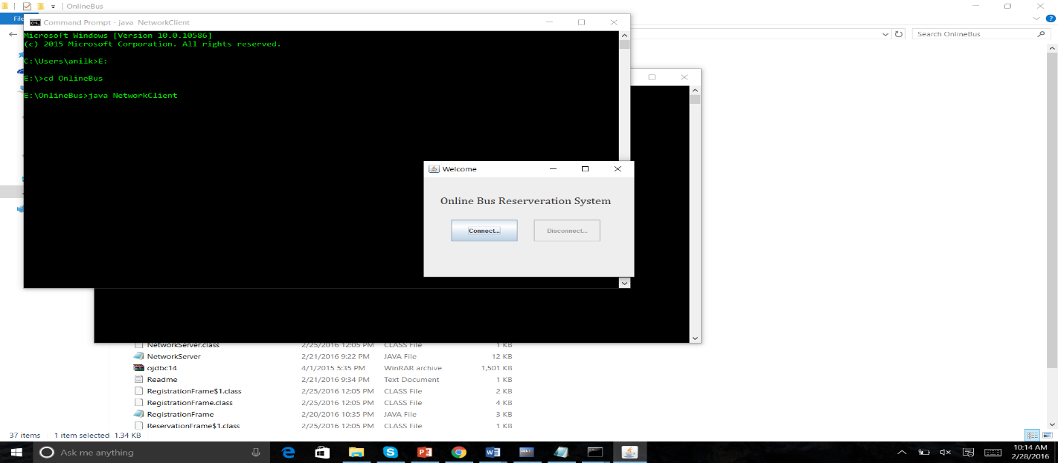

The Register button is used for creating new user records. Any new users coming to this page can register to this website by providing required details.

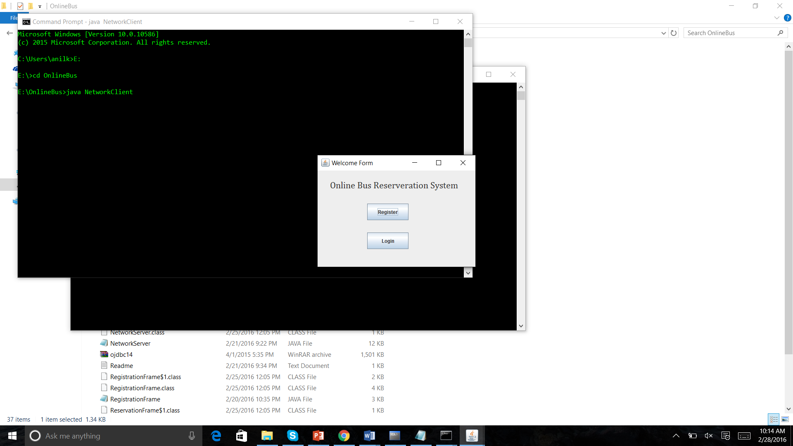

Name, password, mail ID, Phone number these four column are filling for registration.

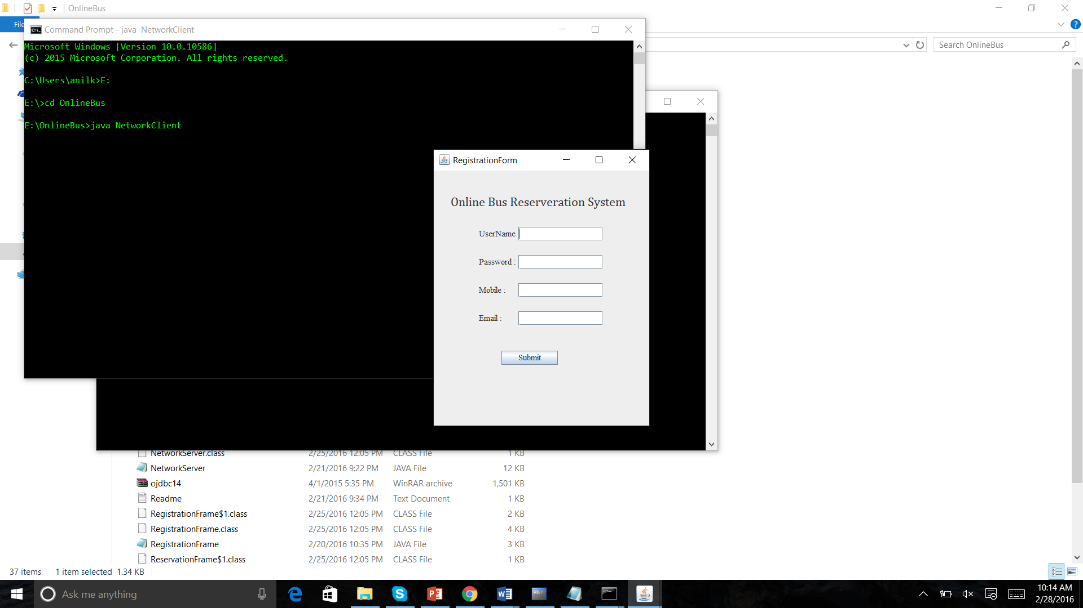

The Login page consists of user id and password of the registered users. registered users can login to this website by using their user id and password.

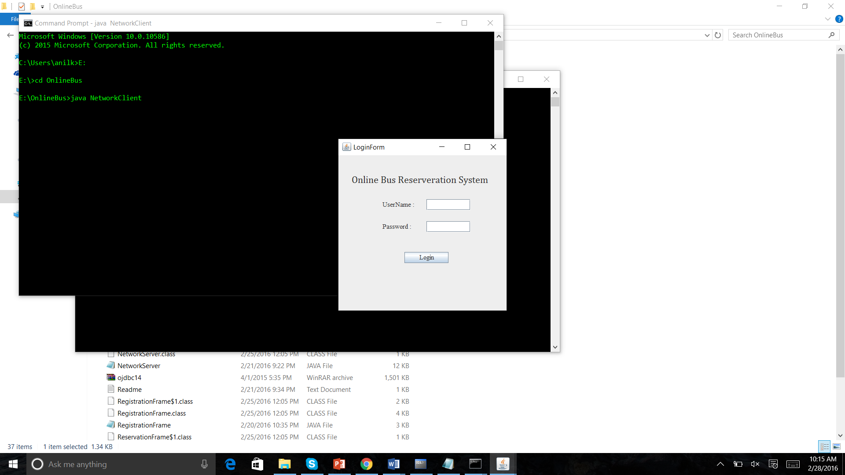

After login we have three columns Reservation, cancellation, availability.

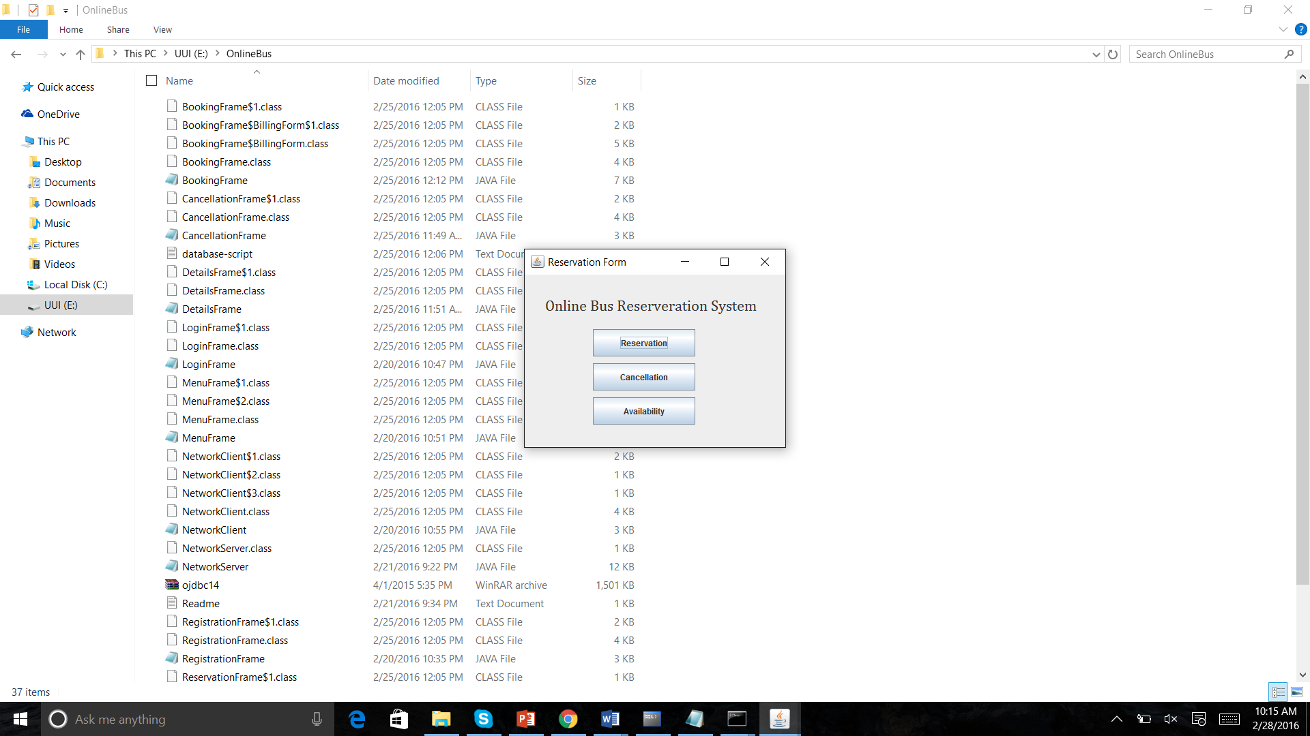

1st check the availability then go to reservation.

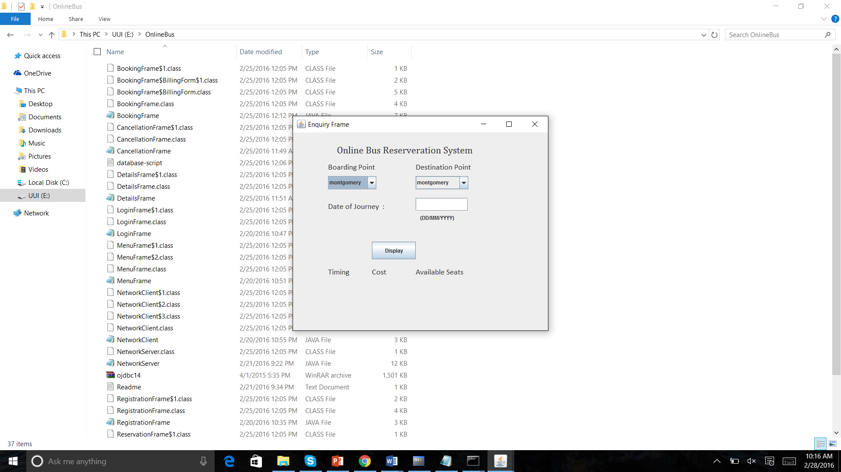

After checking the availability then book the ticket for vacant seat. We are creating three areas. (Montgomery, troy, Dothan)

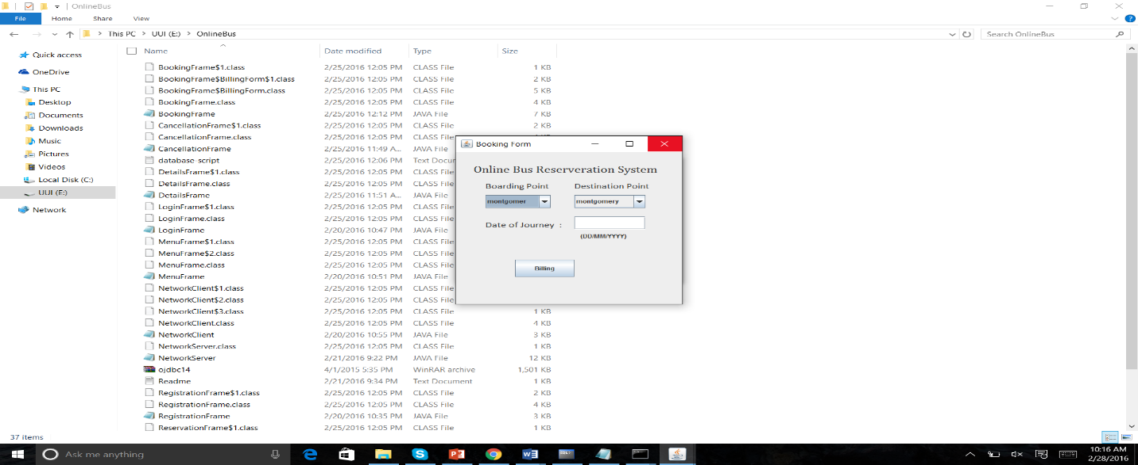

Now we have to select the seat of the passenger. And then proceed to the billing section by clicking the button submit.

We are creating 20 seats in a bus(vehicle), if any seat is vacant select that seat.

Now if any case if passenger wants to cancel his journey, his status is set as cancelled. now with the cancellation of one ticket the available seats in the website is increased by one and booked seats is decreased by one.

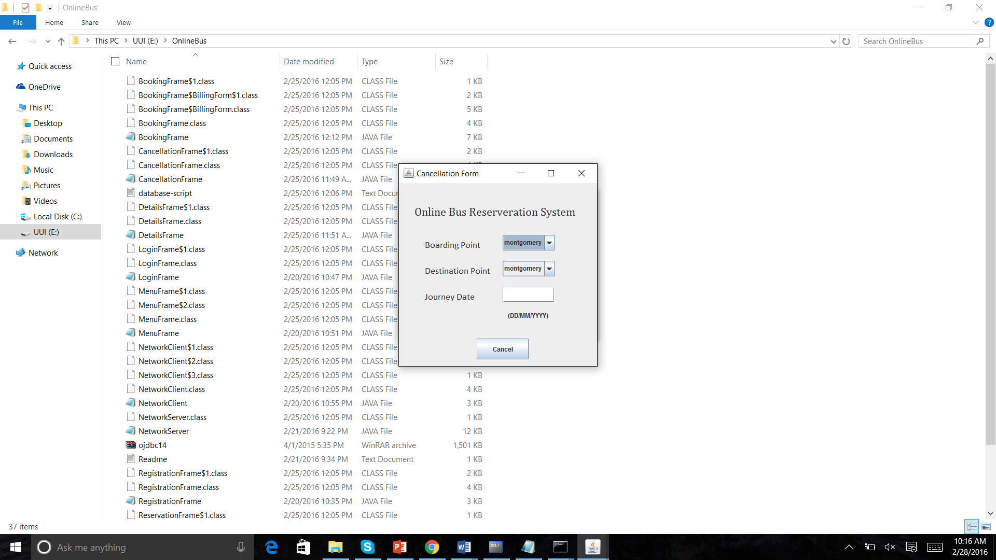

The purpose of bus Reservation System is a software application which provides the bus timing details, reservation, billing and cancellation.

Using this project person can perform operations like finding out the bus timings and to know information about seats and availability etc.